**Introduction:**

In Lab 3, I used binary trees to solve an interesting anagrams problem. In this lab, I was asked to solve exactly the same problem using B-Trees. I ran different scenarios to compare the performance of AVL, Red-Black, and B-Trees. For B-Trees, I ran multiple experiments using different *degrees (max_num_of_keys)* to understand how the parameter was affected by the performance of my solution. I created tables and plots to report your findings. Justifying my selection of experiments and explain why you think those experiments help you compare the different data structures.

**Proposed solution design and implementation:**

In order of finishing this method first of all I got to translate my last RB and AVL tree in order to compare the work with my B-tree which was different and harder than I expected because I did not understand the implementation for these two types of trees into a B-tree.

After getting the B-Tree python class, I got to understand why B-Tree was so different than Binary Tree; in order of finishing this lab I got help from my professor Diego Aguirre in order to understand better what to I have to do.

Once I was done with the test cases of my RB and my AVL I was ready to read the file which was hard to transverse because my computer is not as powerful as I imagined so I created a simpler Text file called example.

**Experimental results:**

I received a problem mainly because I did not import the import matplotlib.pyplot as plt library which gave me a an error immediately ; after looking into my code I saw my code multiple times used “” this insetad of ‘’ in order of comparing and input to an actual number

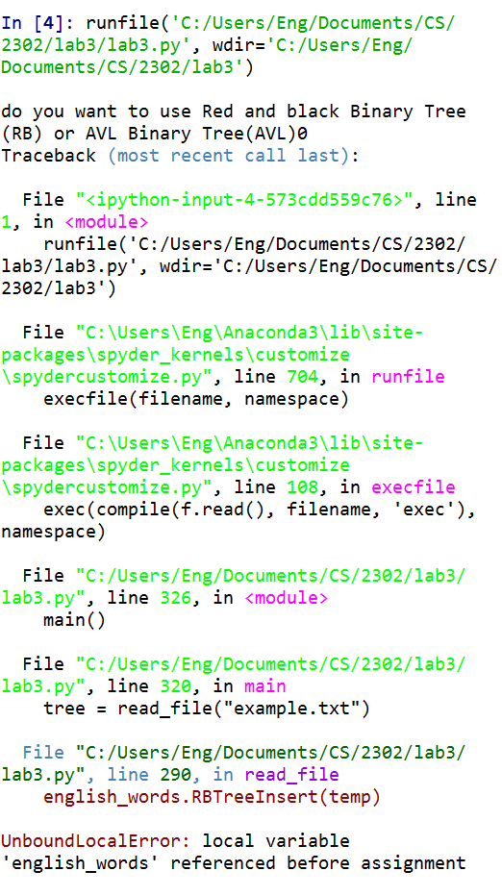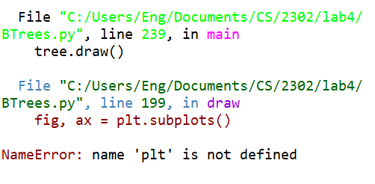

Then I didn’t know how to transverse into the method so I did firstly a base recursive method, then asked my professor if I was on the right way.

After receiving help, I saw the same mistake I got on the avl method which was wrong because I was putting self inside the method instead of putting self at first

Finally, I went to my solution because I was traversing into the same line of comment and instead of changing it I was only looking for another mistake

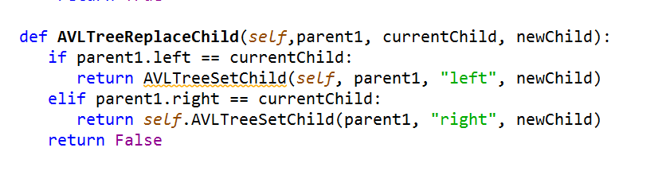**Conclusion:**

**Comparison tables of Binary Tree and B-Tree:**

After several experiments I made this conclusion

|  |  |
| --- | --- |
| B-Tree | Binary Tree |
| Can have more than two children becoming it faster at searching | Only has two children |
| Inserting in a B-tree is more complicated than binary search tree, you have to split the node array into two | Faster in order of inserting than B-Tree |
| In order of balancing B-tree does not have to move to much as Binary Tree | Binary tree increases also in height at the bottom which can give you a worst scenario if you are not quite good at tracing. |
| No need of much memory but it needs a better RAM in order of completing it in a much faster way | You need more RAM when you are storing into a B-tree because it needs more time and memory |

I felt challenged at the time finishing my lab because I had to make some experiments using and comparing two data structures in order to read file and stored in a better way. Finally my running time was O(logn) for inserting, deleting, and searching in BOTH cases.

**Source Code:** 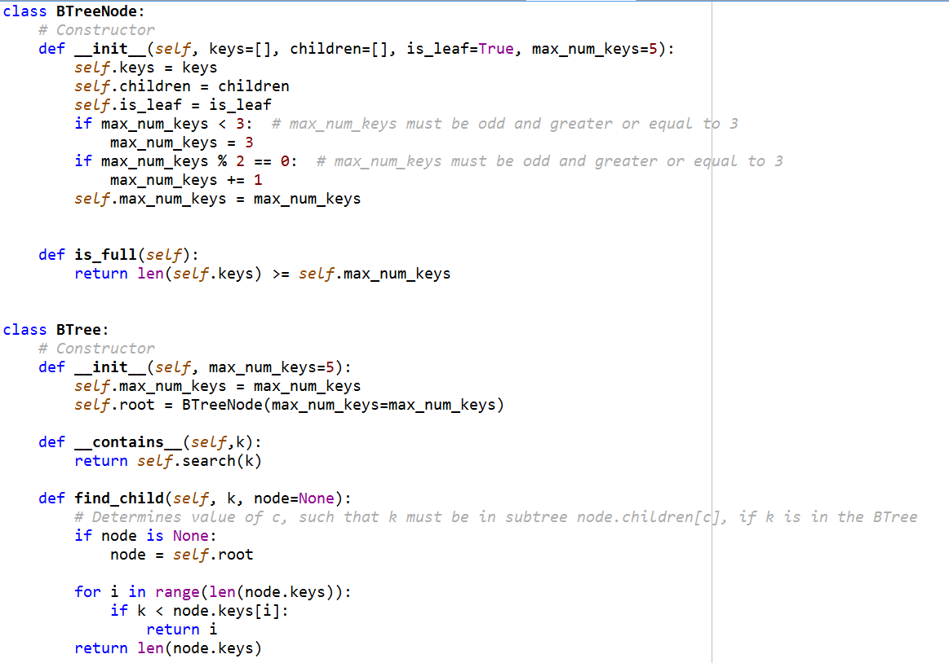

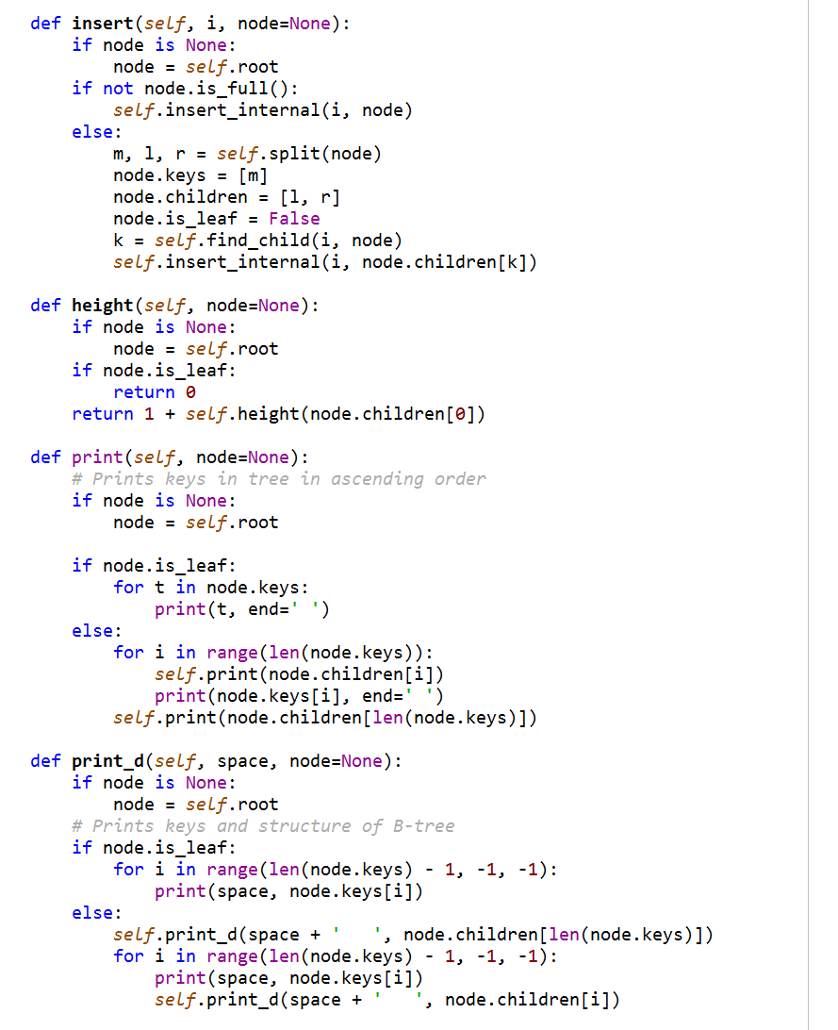

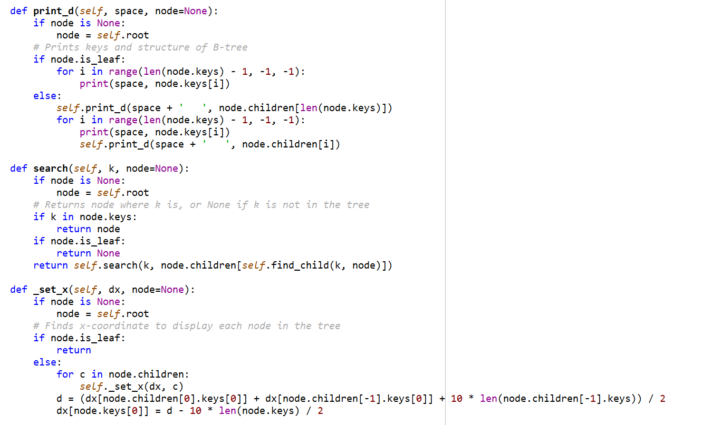

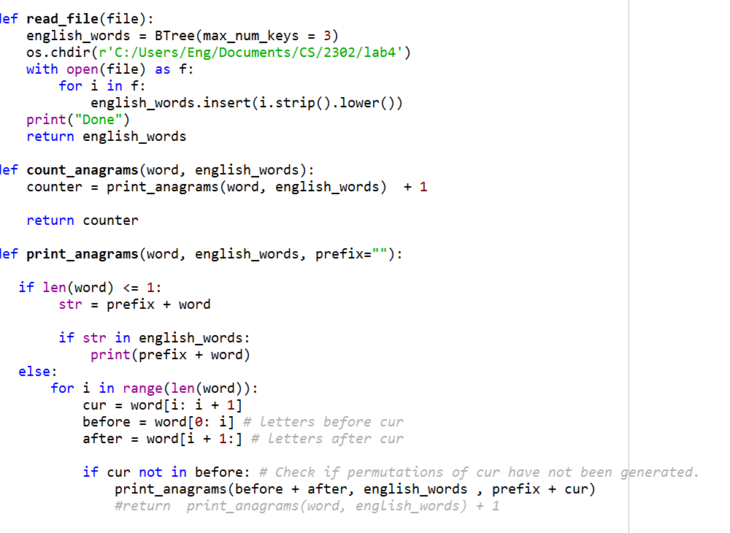

Main

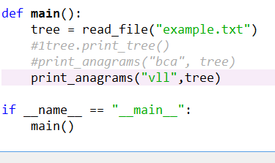

**Academic Honesty**

“I certify that this project is entirely my own work. I wrote, debugged, and tested the code being presented, performed the experiments, and wrote the report. I also certify that I did not share my code or report or provided inappropriate assistance to any student in the class.”